COVID-19 pandemic has unleashed the economic crises more so for the women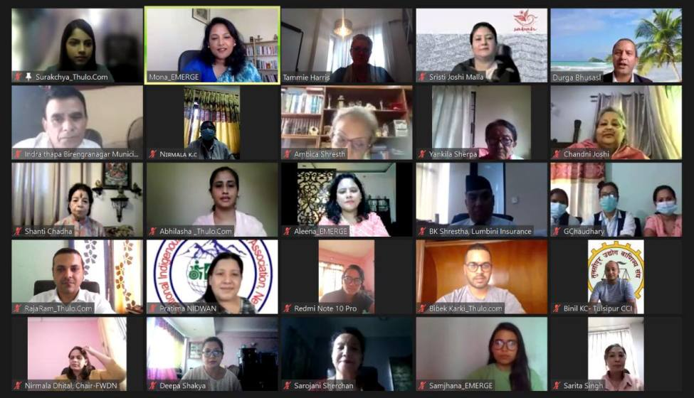 businesses (women owned/led Micro small and medium enterprises -MSMEs). With lives and livelihoods affected by disasters like COVID-19 a robust intervention is needed to support women businesses as well as women home-based producers across the country for their sustainable economic recovery and resilience to various types of disasters.

With an aim of providing women businesses as as well as women home-based producers a platform to enable the women producers both in the formal and informal sector to brave the COVID impasse and to equip them with the necessary skills and information to be resilient during disasters beyond COVID Thulo.Com together with Enterprise for Management, Economic Reform and Gender Equality (EMERGE) is implementing a project “Fostering Resilience of Women Led Businesses (including home-based women producers) and Consumers” with support from USAID - Tayar Nepal program.

Thulo.Com and EMERGE conducted a virtual inception meeting today on 18th August, 2021. The participants in the program included women businesses, representatives from ministries, local government, banks, insurance, tech companies, development agencies, private sector and media.

Welcoming the participants in the program Dr, Mona Shrestha Adhikari, CEO, EMERGE shared the project highlights. She mentioned that the main objectives behind this project are to impart skills on Disaster Risk Reduction and Management (DRRM) integrated with holistic business management and to enhance economic resilience of women led businesses and disaster resilience of potential consumers. The project’s geographical focus is in 5 provinces, 10 districts and 15 municipalities. She also shared that they are collaborating with organizations namely SAARC Business Association of Home-Based Workers (SABAH Nepal), National Indigenous Disabled Women Association Nepal (NIDWAN), Federation of Business and Professional Women Nepal (FBPWN) and Federation of Women with Disability-Nepal (FWDN) along with four municipalities: Birendranagar, Surkhet district; Godavari, Kailali district; Neelakantha, Dhading district; and Tulsipur sub metropolitan city, Dang district - that are working areas of Tayar Nepal.

In her opening remarks Ms. Tammie Harris, Chief of Party, Tayar Nepal shared that this project is an extension of last year’s 4 month pilot project named “Revitalizing Women’s Businesses Amidst COVID-19 Pandemic”. She pointed out that private sector engagement, gender equality and social inclusion are cross-cutting themes for Tayar Nepal. She believes that this project will equip women entrepreneurs and producers with tools to enhance their business resilience and to assist them to explore more entrepreneurship opportunities in producing the products that will contribute in enhancing the resilience of communities. She also appreciated the in-kind contribution of Thulo and the EMERGE team in this project.

Mr. Durga Prasad Bhusal, under-secretary, Ministry of Industry Commerce and Supplies (MOICS) in his special remarks expressed that this project is rightly timed to grab the opportunities presented by ecommerce and mitigate the challenges brought by the disasters like COVID-19 pandemic. On behalf of MOICS, Mr. Bhusal expressed enthusiasm in supporting this project and beyond to enable MSMEs including women businesses to benefit from ecommerce regulations and plans of the government.

The representatives from Neelakantha municipality - Ms. Nirmala KC and from Tulsipur - Ms. Maya Shrestha, also shared their ongoing work with women entrepreneurs and suggested for more comprehensive packages to be delivered in future.

Ms. Surakchya Adhikari, COO of Thulo.Com and the focal person of the Project shared the activities that will be covered during the project. She highlighted the effort of being as inclusive as possible by including project beneficiaries from formal and informal businesses, both urban and rural areas as well as from marginalized and socially excluded communities such as women with disabilities and women from ethnic groups. She highlighted that the project aims to upskill 120 women entrepreneurs and home based producers among which 40 will get access to online promotion and sales along with developing a dedicated App to disseminate information related to DRRM.

Srishti Joshi Malla, Chairperson, SABAH Nepal shared that providing a digital platform to enhance the financial activities of women entrepreneurs and home based producers through this project is commendable. Ms. Pratima Gurung, president, NIDWAN appreciated the collaboration and believed that this project will not only help in economic empowerment but also in enhancing/ imparting gender and social inclusion.

to give NIDWAN’s beneficiaries an opportunity for economic empowerment during this time of pandemic. Ambica Shrestha, President, FBPWN, stressed that many women entrepreneurs are home based and in today’s time digitization of business is essential. Nirmala Dhital, Chairperson, FWDN, also expressed that this project is very inclusive in all means and that it will serve as a big platform for women with disabilities to connect and work with bigger organizations. Towards the end, Ms. Chandni Joshi, Patron of SABAH Nepal shared that this project is a quantum leap that has the potential to set an example for many organizations in Nepal. This will be a great roadmap for organizations working at different levels.

Dr. Mona Shrestha wrapped up the program with acknowledgement to Tayar Nepal team and all the participants of the inception meeting. She also requested support from government agencies, development partners, private sector and media agencies to engage with them in this project and beyond for example in Udhyami Utthan - an entrepreneurship empowerment initiative of EMERGE and Thulo.com, in enhancing economic recovery of the country alongside harnessing digital and entrepreneurial skills of women businesses.

*Originally Released on: [Aug 19, 2021](https://thulo.com/explore/?date=1629310500) [Thulo .Com](https://thulo.com/explore/?author=Thulo+.Com) [Udhyami Utthan (UU) Press Release](https://thulo.com/udhyami-utthan-uu-press-release/)*